St. Francis Xaiver’s College

Library Service Team

Attendance Program Notes

|  |  |  |  |
| --- | --- | --- | --- |
| **Constants and Variables** | | **Function/Usage** | |
| **Const** version | | Stores the current version in integer. | |
| **Const** devphase | | Stores the current development phase in string. | |
| **Var** member : **array**[1..100] **of** Membertype | | Name : **string** | Stores the names of the members. |
| ID : **string** | Store the IDs of the members. |
| dow : **string** | Store the duty day of week of the members. |
| Status***X*** : **string** | Stores the duty statuses of the members. |
| CICount***X*** : integer; | Stores the differences between total duty counts and checked in duty counts of the members. |
| SCount***X*** : integer; | Stores the shift counts of the members. |
| LCount***X*** : integer; | Store the late counts of the members. |
| WCount : integer; | Stores the warning counts of the members. |
| *Remarks:*  ***X*** *can be* ***M****,* ***L*** *or* ***AS****, stand for Morning, Lunchtime and AfterSchool respectively.* | |
| **Var** num : integer | | Stores the total number of member. | |
| **Var** adminmode : boolean | | True if admin is logged in, otherwise false. | |
| **Var** user : **string** | | Stores the current user type, {Admin, User}. | |
| **Var** cmd : **string** | | Stores the command entered. | |
| **Var** directory : **string** | | Stores the current directory. | |
| **Procedures and Functions** | **Function/Usage** | | |
| **Procedure** Error; | Return corresponding error messages when error code is input. | | |
| **Procedure** admin; | Admin password validation.  If password is correct, adminmode := true, unlocking admin commands.  Enhancement: Encryption of Password | | |
| **Function** getDOW; | Return corresponding day of week when its id is input. | | |
| **Function** getDOWid; | Return corresponding day of week id when day of week string is input. | | |
| **Function** L0; | Add a 0 before strings that are converted from 1 to 9 *[int]*. | | |
| **Function** time_; | Return current time as a string. | | |
| **Function** datetostr; | Convert TDateTime type to String type. | | |
| **Procedure** initializeMember; | Read the member list from Member.txt.  Return error if Member.txt does not exist. | | |
| **Function** period; | Return duty period according to current time.  Return 0 if it is no during any duty periods. | | |
| **Procedure** genabs; | Create an empty duty log if does not exist.  Statuses of all members are set to be ‘Absent’. | | |
| **Procedure** initializeStatus; | Read all the current statuses existed to the program if the duty log has already been generated. | | |
| **Procedure** initializeCICounts; | Add 1 to CICount of on duty members. | | |
| **Procedure** initializeData; | Read all the current data from MemberData.txt if it already exists. Otherwise, generate an empty text file. | | |
| **Procedure** SaveRecord; | Save all record to both duty log and MemberData.txt | | |
| **Procedure** checkin; | Change the status of members to Present if not on duty, else OnDuty, and Late if late. | | |
| **Procedure** resetstatus; | Reset the selected status to Absent. | | |
| **Procedure** NtdAbs; | Set the selected status to NtdAbs and increase the member’s SCount***X***. | | |
| **Procedure** warn; | Increase/Decrease the member’s WCount by 1. | | |
| **Procedure** gen; | Generate specified list (total) to print it on screen. | | |
| **Procedure** list; | Generate specified list (today) to print it on screen. | | |
| **Procedure** editFile; | Guide to Member.exe. | | |
| **Procedure** help; | Generate help list. | | |
| **Procedure** start; | Start-up screen. | | |
| **Procedure** readcmd; | Read command. | | |
| **Main** | Start-up initialization. | | |

How to Use the Program

1. Starting Up Screen

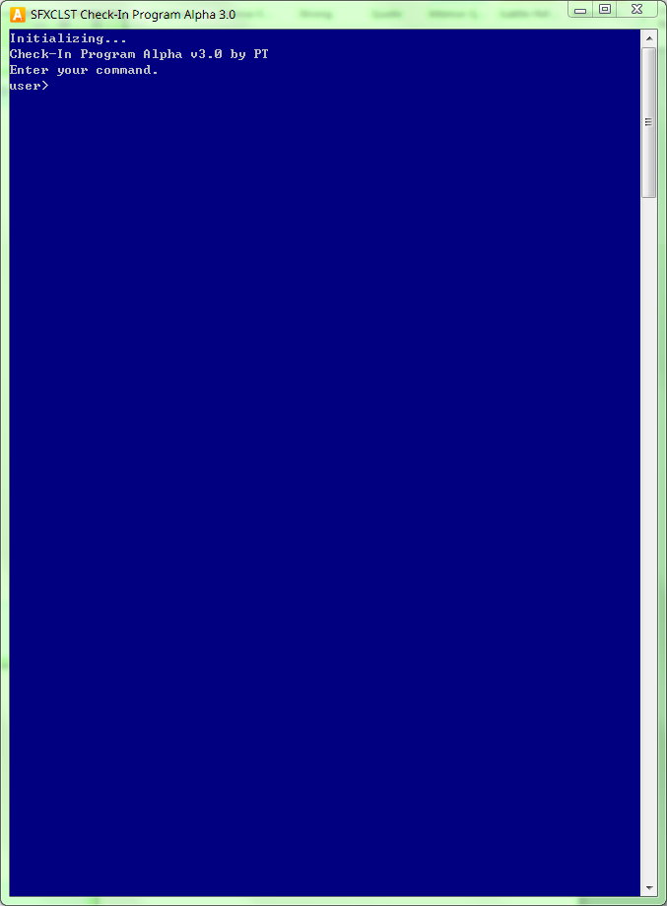

* Potential Warning 1

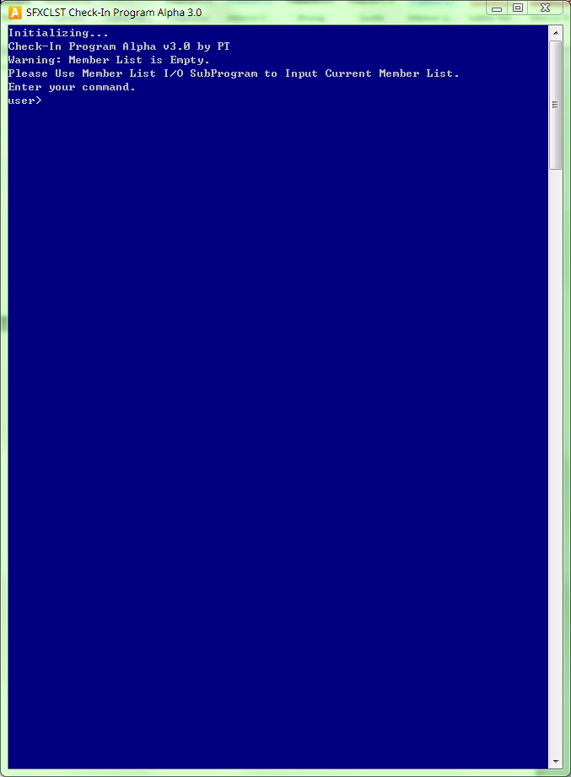

Cause:

Member.txt does not exist in the directory.

Fix:

Contact the current programmer, and have him generate a proper member.txt

Note:

This message will ONLY appear once, next time when you reopen the program, the member list could be still empty but the warning will not show (as the program would automatically generate a blank member.txt after the warning message is shown)

* Potential Warning 2

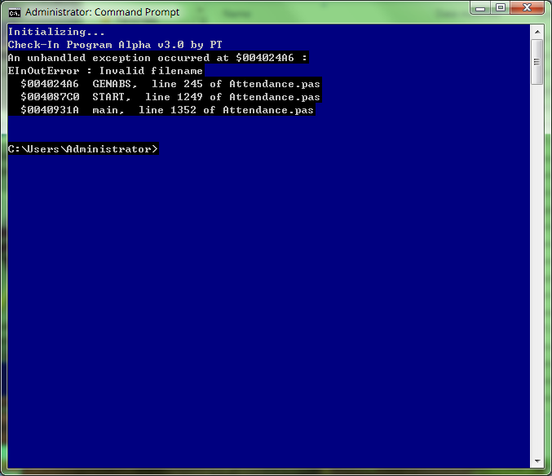

Cause:

The program is opened on Saturday or Sunday.

Fix:

Do not open the program on Saturday or Sunday, if it is weekdays, check the date settings.

1. Checking In